Characterization of Soil Microbial Communities and the Influence of Varying Viticulture Practices

**Abstract**

Vineyard cropping levels and associated fruit quality are tied to vineyard soil characteristics such as texture and availability of minerals, water, and nutrients. ‘Healthy’ vineyard soil contains the appropriate nutrients in sufficient quantities, and there is increasing evidence that soil microbial communities play a vital role in maintaining this balance. The long-term benefit of understanding the composition of soil microbial communities and their function in a specific soil system can allow viticulturists to adopt vineyard practices that maintain healthy soil communities.

The main objective of this research is to characterize vineyard soil microbial communities throughout the growing season in a California Central Coast vineyard under varying vineyard practices. A vineyard block totaling in three acres was divided into three separate units to assess the effects of herbicide use, fertilizer use, and cover crop cultivation on soil chemical and physical properties, vine health, and resulting wine products.

Identities and relative abundance of microbial communities were determined for each replicate by utilizing a high throughput DNA extraction kit and analyzing DNA for the16S or 18S ribosomal RNA gene. Chemical and physical properties of the soil were also determined, including nitrates, phosphates, carbon/nitrogen ratio, organic matter, micronutrients, texture, and bulk density.

**Introduction**

The management of soil health using more sustainable practices has become a subject of increasing interest due to its ecological and economical importance. The term soil health consists of a dynamic definition dependent on the intended use of the soil, and therefore it is important to define each definition of soil health as an individual body (Nielsen and Winding, 2001). In an agricultural setting, soil health can be defined as the net result of continuously applied conservation practices and degradation processes, which are highly dependent on the microbial communities of the soil ecosystem; all of which influence crop health and productivity, environmental health, and food safety (Halvorson et al. 1997; Parr et al. 1992). To further narrow the definition of soil health, rigorous field and lab work needs to be performed to better understand the specific indicators and the requirements to maintain a healthy soil within each setting.

The use of current conventional viticulture management practices has been able to meet the markets demands, however, at a cost to soil health (Leite et al., 2009). The negative effects on soil health by conventional practices have led to an increase use of favorable organic and biodynamic management practices. These practices include the use of organic fertilizers, cover crops, annual green mulching by tillage of cover crops and discontinued use of herbicides. When these management practices are used dynamically, by adjusting agricultural practices to fit the needs of a healthy soil, they have been shown to improve vine health and grape quality (Reeve et al., 2005).

In this study, vineyard soil microbial communities in a California Central Coast vineyard were characterized throughout the growing season under varying non-dynamic vineyard practices. A vineyard block totaling in 3.5 acres was divided into three separate units to assess the effects of herbicide use, fertilizer use, and cover crop cultivation on soil chemical and physical properties, vine health, and resulting wine products.

Identities and relative abundance of microbial communities were determined for each replicate by utilizing a high throughput DNA extraction kit and analyzing DNA for the16S or 18S ribosomal RNA gene. Chemical and physical properties of the soil were also determined, including nitrates, phosphates, carbon/nitrogen ratio, organic matter, micronutrients, texture, and bulk density.

**Methods and Material**

2.1 Experiment Design and Treatment Type

The study area consisted of a 3.5 acre vineyard plot (Figure 1). The plot was divided into three separate blocks corresponding to each experiment type. The cover crop experiment is located within the western portion of the vineyard block and is separated into three different treatment types; high water usage cover crop, low water usage cover crop, and residential vegetation was used as the control. Each treatment was further divided into six separate sampling blocks with two sampling blocks randomly placed within each sample row. Each delineated sampling block was set to a width of four rows and a length evenly spaced to the length of the experiment block. Sampling blocks were buffered to adjacent sampling blocks by four non treated rows. Each treatment consisted of 6 sampling blocks for a total of 18 sampling blocks for all three experiments. The second experiment is a fertilizer experiment, located between the cover crop and herbicide experiments, and consists of three different treatments: a synthetic fertilizer treatment, an organic fertilizer treatment, and a no fertilizer application control. The fertilizer experiment followed the same sample spatial parameters as the cover crop experiment. The herbicide experiment is located within the eastern most portion of the vineyard plot consisting of two treatments: herbicide use and no herbicide use. Each treatment was divided into six sub blocks and with two sub blocks randomly paced with each sampling row for a total of 12 treatment sub blocks. Experiment set up is outlined in Figure 1.

The high water usage cover crop treatment comprised of the Oso Plowdown® cover crop mixture. The mixture consisted of 30% pea, 10% radish, 10% mustard, 30% bell beans and 20% barley. The low water cover crop is comprised of the Double Hitter® cover crop mixture. The mixture consisted of 30% brome, 40 annual rye grass and 30% clover. Cover crop mixtures were provided by Helena Chemical®. The no cover crop treatment consisted of resident *Trifolium dichotomum*, *Lolium multiflorum* and *Oxalis claifornic*a and other native and nonnative grasses.

The synthetic fertilizer treatments were applied by foliar application, banded application on vine rows and side dressed along vine rows near the base of the vines. Banded application consisted of a 32 inch wide spray band between vines. Side dress application consists of a focused spray application at the base of the vines. Foliar applicate fertilizers included 2-2-0 +2% Micros Blend, Organic Triger, Acadian 0.1-0-5.0 and 2-0-8 +4%Ca Blend. Fertilizers applied on vine rows included CAN-17 and C.T.I. Dairy Compost / 95% Gypsum – (50/50 blend). Cerys 5-2-15 was the only fertilizer side dressed along vine rows. The organic treatment consisted of the same application types as the synthetic fertilizer treatments. Foliar fertilizes included 2-2-0 +2% Ca +Micros Blend, Organic Triger and Organic BioLink MicroNutrient Fertilizer. Side-dressed applicate organic fertilizers included True 413 and Soil maximizer. C.T.I.Dairy Compost/95% Gypsum-(50/50 Blend) was banded on vine rows. The no fertilizer control consisted of only foliar applications of 2-2-0 +2% Ca +Micros Blend and Organic Trigrr. Chemical composition, application rates, amounts and manufacture information are described in the master treatment table (Please see 2016 application summary in master hard drive).

The herbicide treatment consisted of four different herbicides: Alion® herbicide, GoalTender®, Roundup PowerMax®, and PHT Crop Oil Concentrate. Each herbicide was applied in between vine rows with a band width of 32 inches. No herbicide was applied to control treatment blocks in this experiment. The non-herbicide treatment was tilled between every other vine row.

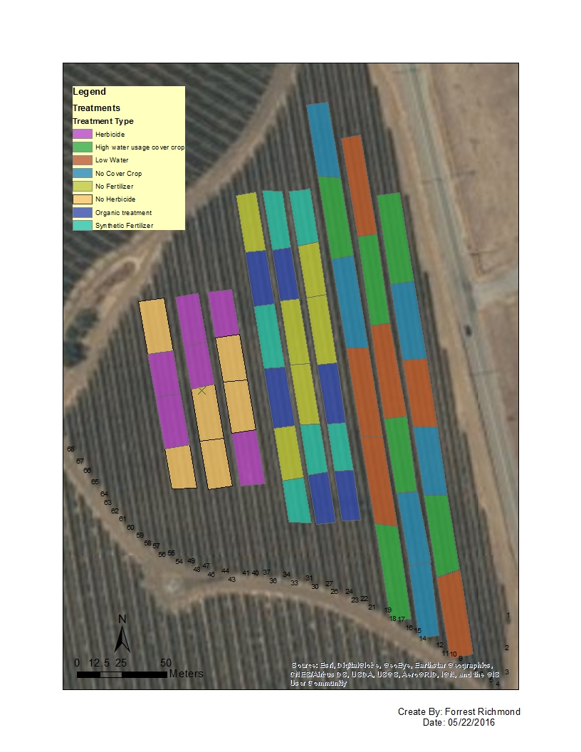

Figure 1: Map of experiment setup using ArcMap GIS Software. The right three rows outline the cover crop experiment, the middle three outline the fertilizer experiment and the left three rows outline the herbicide experiment. Both the cover crop and fertilizer experiments consists of three different treatments and the herbicide experiment consist of two experiment. Each treatment sampling block is delineated into rectangles and represented by color.

**Soil Collection**

Sampling methods differed depending if the soil was to be used for chemical/ physical analysis or microbial analysis. Collection dates were determined by significant events during the wine grape growing season. The first collection, designated bud break, took place mid-March, followed by bloom in mid-May, verasion in min-July and harvest in late September. Soils used for microbial analysis were collected in triplicates for each of the six treatments and placed within a zip lock bag (Figure 2). Soil was collected at a depth of 10 cm using a soil core sampler. The coring device was sterilized using a 70% ethanol solution between treatment types. The samples were further processed as described in the next section. Soils sampled for chemical and physical property analysis were collected using a spade shovel at locations adjacent to the soils collected for microbial analysis. Sample depth remained at 10 cm. Three samples were collected within each treatment block and added to a five-gallon bucket. Sample volumes were approximately a third shovel full. Each five-gallon bucket was homogenized and separated into two-gallon zip lock bags as replicates.

**DNA Soil Preparation**

Composite samples corresponding to each treatment were randomly combined into 1 gallon zip lock bags to form three new composite samples to reduce bias due to the spatial difference of each treatment block. Weights were recorded for each composite sample used for microbial analysis to determine the minimum weight of each composite samples from each treatment. This value was used as the maximum weight to be taken from each composite sample when combining composite samples into triplicates. The final samples were then homogenized within each bag using a rolling pin.

Two sub-samples of approximately 0.250 g of soil from each composite sample were weighed and added to a microfuge tubes for a total of 192 microfuge tubes. The subsamples were then transferred to a 96 well plate, provided with MoBio Power Soil 96 well plate extraction kit, by cutting the bottom of each centrifuge tube to create a funnel for easy transfer.

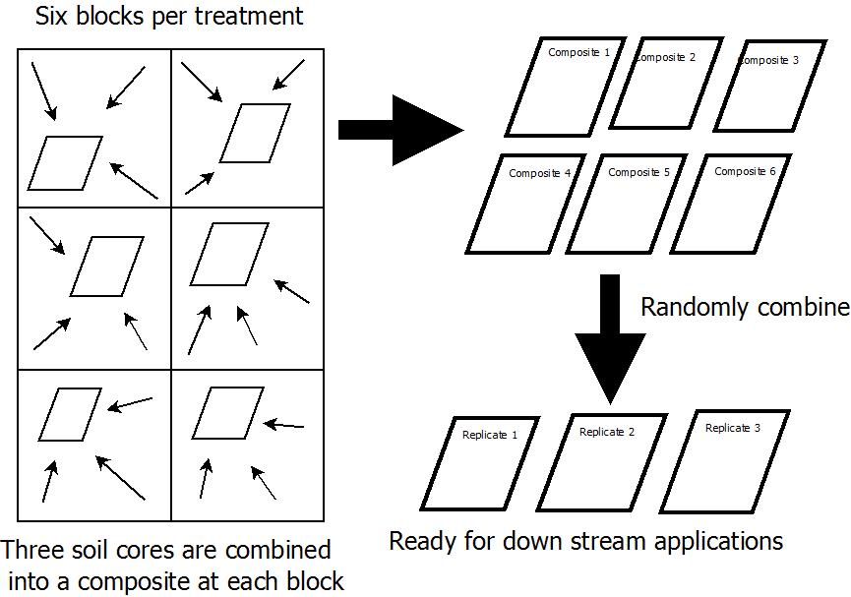

Figure 2: Figure 2: Work flow for sampling procedure for each treatment type. Three composite samples were taken from each treatment block and combined into a composite sample. Composite samples were randomly paired and combined to form three replicate samples ready for downstream applications.

**Water Content Analysis**

Excess soil collected for microbial analysis was used to determine gravimetric water content $(θ_{g})$. Three random samples of approximately 20.0 g of non-air dried soil from each collection period was placed within a pre-weighed tin and placed in an oven for 24 hours at 105 $℃$. Samples were then reweighed and $θ_{g}$ was determined using equation 1. Standard operating procedure is outlined in the Soil, Plant and Water Reference Methods for the Western Region Handbook (Miller, 2005).

(1) $θ_{g}=\frac{mass of soil-mass of oven dried soil}{mass of oven dried soil} ×100\%$

**Carbon Nitrogen Analysis**

Percent carbon (%C), percent nitrogen (%N) and carbon nitrogen ratios (C:N) were determined using an Elemental Analyzer. Standard operating procedure is outlined in the Soil, Plant and Water Reference Methods for the Western Region Handbook (Miller, 2005). Samples were run in duplicates using the soil from the microbial analysis composite samples. Approximately 1000 mg of soil was added to a crucible and placed within the auto sampler. Pure glutamic acid was used as an initial calibration verification and standard reference material (SRM265) was used as a continuous calibration verification every 8 samples as a quality control method. Standard references were obtained from the U.S. Department of Commerce National Institute of Standards and Technology, Gaithersburg, MD.

**DNA Extraction**

Microbial DNA from the soil was extracted using the MoBio Power Soil 96 well high throughput extraction kit. Each sample was extracted in duplicates for a total of two 96 well plates and extracted using the centrifugation method outline in the standard operation procedure provided with the kit.

**Microbial Biomass**

Microbial biomass as milligrams of double-stranded DNA (dsDNA) per gram of soil was determined (please see master hard drive). Concentration of dsDNA was determined for each replicate using a BioTek Cytation5® UV-Vis plate reader. An external calibration curve of 10 ng/mL, 1 ng/mL, 0.1ng/mL and 0.01 ng/mL λ-dsDNA solution was used. Standard solutions were created using stock 500 ng/ml λ-dsDNA and molecular H2O.

**DNA Sequencing and Analysis**

Extracted DNA from the soil was sequenced by MR. DNA in Shallowwater, Texas, with focus on the 16S and 18S ribosomal RNA. Sequencing was performed using next generation ion torrent sequencing.

**Soil Chemical properties**

Single composite soil samples were split into duplicate samples and analyzed by Precision Agri Labs in Madera California. Samples were analyzed for pH, organic matter (OM), cation exchange capacity (CEC), Base saturation (%BS), Ca, Mg, Na, Cl and SO42, in meq/L along with NO3-, PO43-, SO42-, Zn, Mn, Fe and Cu in ppm.